**Faculty of MITS**

[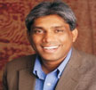](http://www.mits-india.org/faculty_details.php?id=1)

**Dr. Saji K. Lukos**

President

[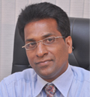](http://www.mits-india.org/faculty_details.php?id=2)

**Dr. Achankunju Pappy**

Principal

[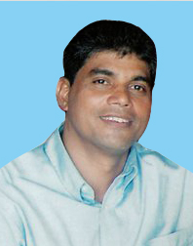](http://www.mits-india.org/faculty_details.php?id=3)

**PD Joseph**

Chief Functionary

[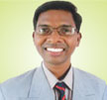](http://www.mits-india.org/faculty_details.php?id=4)

**Rev. (Dr.)Hruda Ranjan Lohora**

Academic Dean

[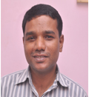](http://www.mits-india.org/faculty_details.php?id=5)

**Rev. Rajan Kochukutty**

Dean of Students

[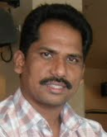](http://www.mits-india.org/faculty_details.php?id=6)

**Rev. Sunil Korada**

Registrar

[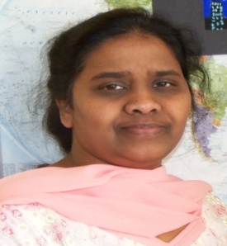](http://www.mits-india.org/faculty_details.php?id=8)

**Mrs. (Dr.) Carolyn Pappy**

Faculty

[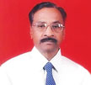](http://www.mits-india.org/faculty_details.php?id=9)

**Rev. Diwakar Londhe**

Faculty

[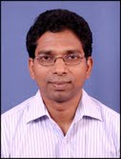](http://www.mits-india.org/faculty_details.php?id=10)

**Rev. Thomaskutty**

Chaplain

[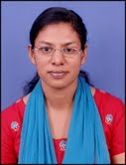](http://www.mits-india.org/faculty_details.php?id=11)

**Mrs. Saly Thomas**

HOD Practical Theology

[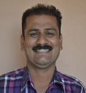](http://www.mits-india.org/faculty_details.php?id=12)

**Rev. Satish Sukhdeve**

Marathi Coordinator

[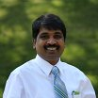](http://www.mits-india.org/faculty_details.php?id=13)

**Rev. Surjit Digal**

HOD Theology

[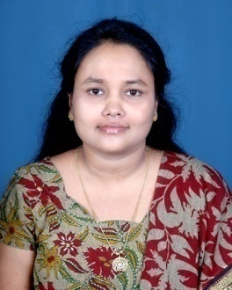](http://www.mits-india.org/faculty_details.php?id=14)

**Mrs. Sucheta Digal**

HOD New Testament

[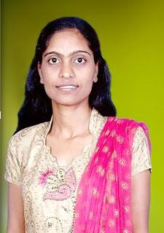](http://www.mits-india.org/faculty_details.php?id=15)

**Mrs. Sarita Samuel**

Faculty

[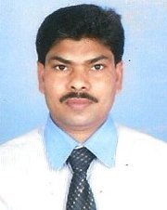](http://www.mits-india.org/faculty_details.php?id=16)

**Rev. Ravindra Kumar Chapdi**

Faculty

[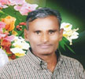](http://www.mits-india.org/faculty_details.php?id=17)

**Dr. Ganeshpanddy**

Faculty

[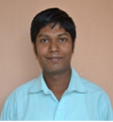](http://www.mits-india.org/faculty_details.php?id=18) Rev. Josfin Raj

Faculty